Your ASD Screening Assessment - What To Expect

Prior to your appointment
Attached to your appointment email you will find a selection of forms for you to complete and return to us ahead of your appointment.

We do ask that these forms are completed and returned to us as soon as possible, and ideally at least 48 hours prior to your appointment, to ensure that we can pass full details on to your assessor ahead of your assessment and that they are able to read through your forms ahead of your appointment.

However, if you experience any difficulties completing and returning your forms via email, please let us know and please bring your completed forms with you to your appointment.

Please note that we are not able to complete the assessment without your completed forms.

You will receive an invoice from us via our invoicing system Quickbooks ahead of your appointment date, and we do ask that full payment is made ahead of your assessment. These emails can sometimes go into the junk mail, so if you do not receive your invoice please check your junk mail folder.

Payment can be made via BACS and full payment details will be on your invoice.

The Assessment

You and your child will meet with one of our fully trained assessors at The Butterfly Room and the assessment will usually take around 45-50 minutes, however we do recommend allowing around 1 hour for your appointment.
The assessment itself is very non-invasive and non-clinical, and you will be with your child throughout your appointment.
The first half of the assessment will be speaking to you to obtain relevant background information such as details around your child’s development history etc. and the remainder of the appointment will be, depending on your child’s age, playing and/or chatting with your child about their likes and dislikes, friends, school and hobbies etc.
Your assessor will not be able to provide you with feedback at the assessment, and again we do want to stress that the ASD Screening Assessment is not a full ASD diagnosis. The Screening Assessment is a semi structured clinical observation of your child to obtain a picture of strengths and differences to inform an assessment for ASD. It is not a standardised assessment nor a diagnostic assessment; the Screening is designed to help support further investigations towards a full ASD diagnosis.

After Your Screening Assessment

After your Screening Assessment, your assessor will write a detailed report outlining observations and concerns for you to share with your GP, School and any other services that you may wish too.
We always aim to send your report to you as quickly as possible and we do our best to send you your report within 12-14 working days, however this can take longer during busy periods and we do thank you for your patience and understanding.
If your report recommends further investigation towards a full ASD diagnosis, we can provide you with the details of a private consultant or advise how you can pursue this via the NHS - if you would like this information, please do just contact us and we will be very happy to send you further details.

Commonly Asked Questions
Is the Screening Assessment an ADHD diagnosis?
The Screening Assessment is not an ADHD diagnosis, however the assessment does include observing for behaviours indicative of ADHD.
Is the Report recognised by the NHS?
Our ASD Screening Assessment is conducted by fully trained assessors and to date we have not received any feedback from patients who have experienced difficulties when presenting the report to their GP or other health professionals.
Is there parking at The Butterfly Room?
Yes we do have parking on site.

Can siblings come into the Assessment?
Unfortunately, siblings are not able to come into the Screening Assessment.
Can siblings wait in our waiting area?
Siblings are not able to wait in our waiting area on their own, all children must be supervised by a responsible adult at all times.

Do you provide a full ASD Diagnosis?
Unfortunately, this is no longer a service we offer, however if following your ASD Screening Assessment your assessor recommends that a formal ASD diagnosis should be pursued, we are able to provide you with information on how you can progress this both via the NHS and privately.

Meet Our Assessors
Your appointment email and letter will tell you which assessor you will be meeting.
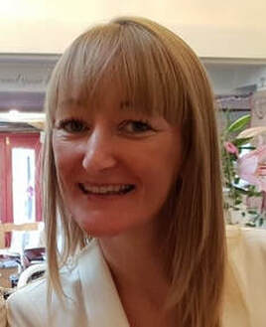
Katherine
Rachel

Ayesha
Naomi
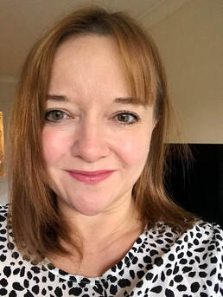
Laura
Melissa

